**Mobile Open Source**

**Software Requirement Specification**

**-Healthly Ever After-**

**32179203 Elijah**

**32152304 Song Minsoo**

**32172429 Ahn Hyunsu**

**32179279 Quentin**

**Table of Contents**

1. **Introduction**

1.1 Purpose

1.2 Intended Audience and Reading Suggestions

1.3 Project Scope

1.4 References

1. **Overall description**

2.1 Product perspective

2.2 User classes and characteristics

2.3 Operating Environment

2.4 Design and Implementation Constraints

1. **System Features**

3.1 Functional Requirements

1. **External Interface Requirements**

4.1 User Interfaces

4.2 Connection Interfaces

1. **Functional Requirements**

5.1 Functional Requirements

1. **Nonfunctional Requirements**

6.1 Performance Requirements

6.2 Safety Requirements

6.3 Security Requirements



**1. Introduction**

**1.1 Purpose**

The purpose of this project is to build a mobile application that encourages users to live healthily.

**1.2 Intended Audience and Reading Suggestions**

The intended audience of this mobile application is any person who wants to start living healthily.

This Software Requirements document is intended for:

* Developers who can review the projects capabilities and have a fully developed understanding of this project, so that they may be able to improve upon or add more features to this project.
* Project testers who may use this document to understand where their effort should be targeted towards, so that they may find weak points or bugs in our project. This allows for testing of our project to be more organized.
* Any and all end users who are interested in what our project aims and intends to do.

**1.3 Project Scope**

HealthilyEverAfter is a flexible, user-friendly mobile application to help users track calorie intake, and amount walked. It will also give the user dietary and exercise recommendations based on height, weight and user activity. HealthilyEverAfter will be able to eliminate the need for multiple different applications to track calories, measurements and exercise amount.

**1.4 References**

* **Nike run**

[**https://www.nike.com/kr/ko_kr/c/running/nike-run-club**](https://www.nike.com/kr/ko_kr/c/running/nike-run-club)

* **Samsung Health**

[**https://www.samsung.com/sec/apps/samsung-health/**](https://www.samsung.com/sec/apps/samsung-health/)



**2. Overall description**

**2.1 Product Perspective**

HealthilyEverAfter is an extremely useful application for those who want to be able to track and moderate the way they are living their lives. All you have to do is download it and you’ll be on your way to living healthily.

**2.2 User Classes and Characteristics**

Any Kind of User:

* HealthilyEverAfter is a simple yet effective fitness application, so anyone with a mobile phone can use it.

Software Developers and Contributors:

* Software Developers: People who have a general understanding of HTML and Cordova, in order to understand and improve upon the source code.
* Translators: Any person who has a very good understanding of a language that isn’t in the current list of translations

**2.3 Operating Environment**

HealthilyEverAfter should run on Operating Systems: iOS(Will need Mac OS to build), Android.

**2.4 Design and Implementation Constraints**

HealthilyEverAfter is designed to be built on the Cordova framework which is HTML, CSS and JavaScript. HealthilyEverAfter is under no public licenses, however, everyone that works on, or is going to work on HEA should credit us as the creators of the source code.

**3.System Features**

* **Description and Priority**

The HEA application tracks the user’s exercise path and calculate it’s distance/calorie burn.

it also recommends the user some customized healthcare routines. The users can also record what they eat each days and this app calculate the total calories.

This project higher in the list which is GPS tracking function has the highest priority.



* Use case diagram

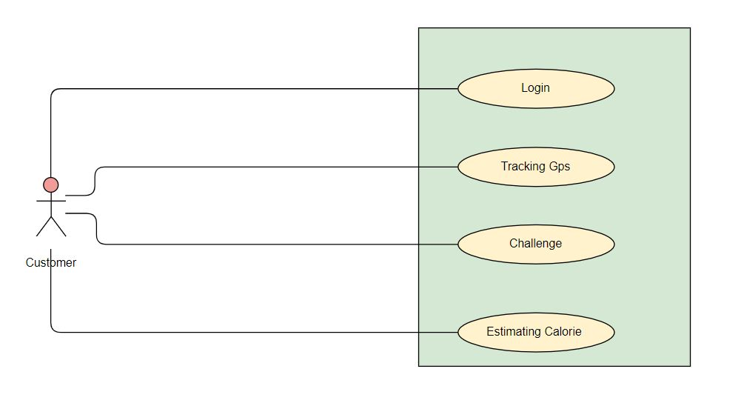

* Sequence diagram

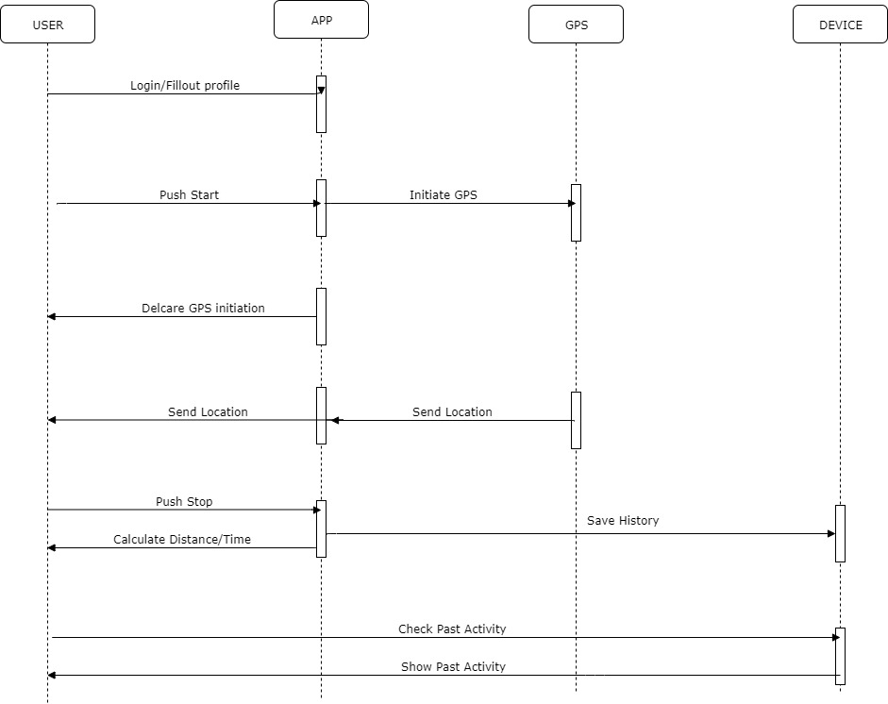



**4.External Interface Requirements**

**4.1 User Interfaces**

User interface of this program is a map with a start button at the bottom of the map, there will be a profile button at the top right and a menu button at the top left. The start button will tell the application to start tracking your GPS location to determine how much you are running. The start button will turn into a stop button after you press it. (Do the profile and menu button functions after we start building the application)

**4.2 Connection Interfaces**

The device that HEA is being used on should have internet connection as GPS tracking is needed. (Still up for debate)

**5. Functional Requirements**

HealthilyEverAfter provides users with the following features:

1.Calorie Tracker: User will enter a certain food and it will give a breakdown of the food item, e.g calories, protein etc. If that item isn’t found then the user is able to note it down manually for their future use.

2.Exercise Tracker: Users will be able to hit a button and let their GPS track how long they will be running, it will give them feedback on speed, total distance, altitude and time. (Will the tracker be able to identify that the person is moving too fast?)

.

3.Challenges: There will be a set amount of challenges given to everyone every month, this is to encourage users to challenge themselves and beat a goal or their friends. (Will there be a fake reward system so that users will have a goal to work towards other than beating a score)

4. Diet Check& Calorie measure: The application will get the diet from the users what they ate in a day5. and calculate following calories.

5. History: Will give the user an overview of what the user has done over the past month and will reset every month.



6.Social Media: This will allow the users to share with their friends how they have been doing so that they can encourage others to join them on their fitness journey, or even challenge their friends

**6. Nonfunctional Requirements**

**6.1 Performance Requirements**

HEA is a light application that needs very few resources from the device in order to work. It is designed to be an application that improves quality of life thus the only background process that is needed is GPS tracking. It will not affect response time or system processes.

**6.2 Safety Requirements**

There is nothing that HEA can do that could affect safety or compromise the device. Any reports saying so are a false alarm, as the application is 100% safe to use. If you have any doubts, HEA is an open source application so you may check it for any viruses.

**6.3 Security Requirements**

There are only two security requirements HEA has is that the user needs to authorize HEA to get the device’s GPS location and to allow HEA to store and retrieve data from the device. 